CVI620 – Assignment 2
Fall 2025

Total Mark: | 7.5 marks (7.5% of the total course grade)
Submission file(s): | - Python files for train and inference
Deadline | - November 27th, 2025

If you are unable to complete the assignment on-time for any legit reason, please provide documentation explaining your absence (e.g., an appointment confirmation or a work letter).

Please submit the submission file(s) through Learn@Seneca. Make sure to use GitHub and provide the link to your GitHub account for all your contributions in the box below:
Project GitHub repository: | https://github.com/jpjain123/CVI/tree/main/Assignment2_Github

Please attach some of your test images along with any required explanations in this document.

- For the Cat and Dog dataset provided in the Q1 folder, perform classification using all the methods you know and try to achieve the best possible result. Compare the algorithms carefully and tune the parameters so that the best result can be obtained.
Save the trained model and test it on several images from the internet. Was the model able to correctly predict the images?

- So, for question 1 dataset, where we had to use the dataset (containing 1000 cat images and 1000 dogs’ images, with 10 test images) given by professor. So first I resize all the images to 128*128, then loaded both the train and test datasets and then compared all the images with all the methods where the best method was RBF method (support vector machine method). Then as we had to download images from internet and check our model if it predicted correctly or not, I downloaded 5 dogs and 5 cat images from images where the model was only able to get 3 of them correctly predicted. Might be because the photos were not all clear as downloaded or the model wasn’t able to process the image if the image was looking slightly different from a dog standing straight.
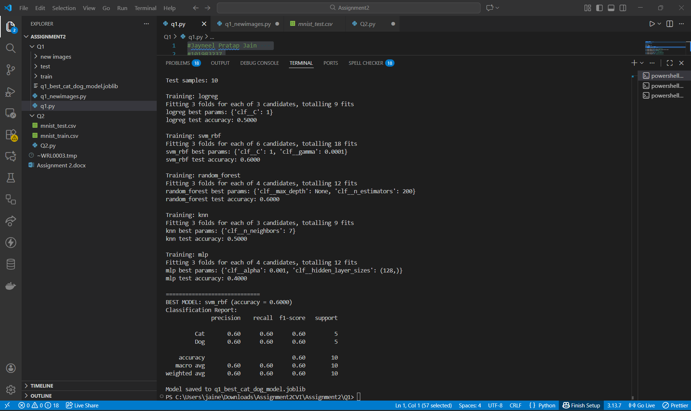
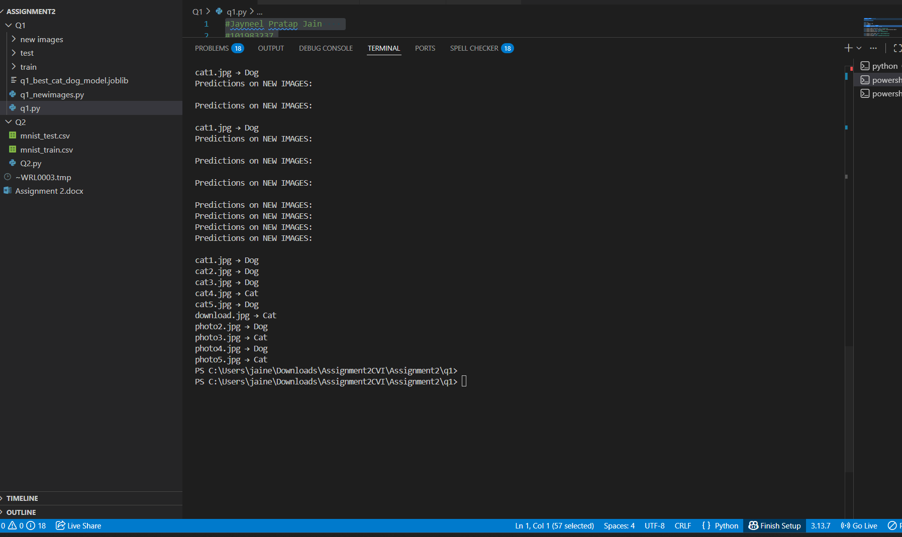

- The MNIST dataset is one of the most well-known datasets in the field of image processing. It contains 60,000 images related to handwritten digits from 0 to 9 and is provided as a CSV file in the Q2 folder. In this file, each image is represented as a flattened vector. Classify this dataset using different methods and try to achieve at least 90% accuracy.

- So, for question 2 we were provided with 2 MNIST dataset and I used all the 5 method to classify yhe dataset and have achieved 97.17% accuracy in multilayer perceptron method.
